**Program 1**

**Trisha Lakhani**

**1BM19CS214**

**PERSON TABLE**

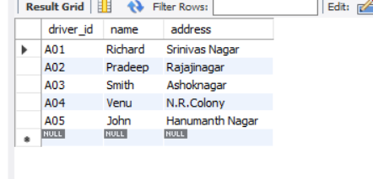

**CAR TABLE**

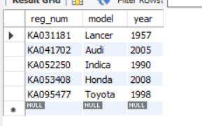

**ACCIDENT TABLE**

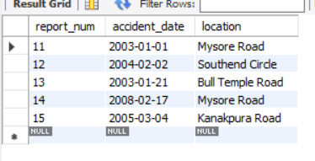

**OWNS TABLE**

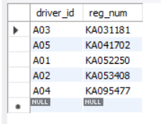

**PARTICIPATED TABLE**

